Measurement Protocol PAX

# General Information:

|  |  |  |
| --- | --- | --- |
| Test date: 14/02/20 | Date prev. test: | Test number: 1 |
| Tested by: Alex Pollak | PAX number: PB-005 | Installed at ant.: 2B |
| Comments: Revision: 1.10 pax controller | | |
|  | | |
|  | | |
|  | | |
| Known problems: | | |
|  | | |
|  | | |
|  | | |

# Setup:

|  |  |  |  |
| --- | --- | --- | --- |
| Power supply: | OK 🗹 NOK 🗆 | Communication: | OK 🗹 NOK 🗆 |
| Supply current +6V: 1.011A | | ssh obs@antcntl | |
| Supply current -6V: 0.108A | | ssh ataant@paxtester | pw: q@n@t |
| Supply current +5V: 0.170A | | telnet pax | “help” |
|  | | CTRL + ] | “close” |

# RF Test with VNA:

### VNA Setup:

|  |  |  |
| --- | --- | --- |
| Load configuration: Passband_PAX.csa | | |
| Freq Start: 1.0 GHz | Freq Stop: 13.0 GHz | Power Level: -20 dBm |
| Averaging: enabled | Averaging count: 15 | N. Points: 801 |
| VNA : Agilent N5230C 10MHz - 20GHz | | |

|  |  |  |  |  |
| --- | --- | --- | --- | --- |
| VNA to PAX connection: | 1m ABC-CA18 Cable + 20dB Attenuator | | | |
| Input Power Level to PAX: (Measured) | @1GHz:  -40.2dBm | @4GHz:  -40.7dBm | @8GHz: -41.2dBm | @12GHz: -41.4dBm |

|  |  |
| --- | --- |
| PAX to VNA connection: | 2m Fibre Cable + Fibre Diode + AOX Amplifier + 1m ABC-CA18 Cable |

### Measured Passband with Attenuator set to 7dB each (Complete Link):

|  |
| --- |
| X |

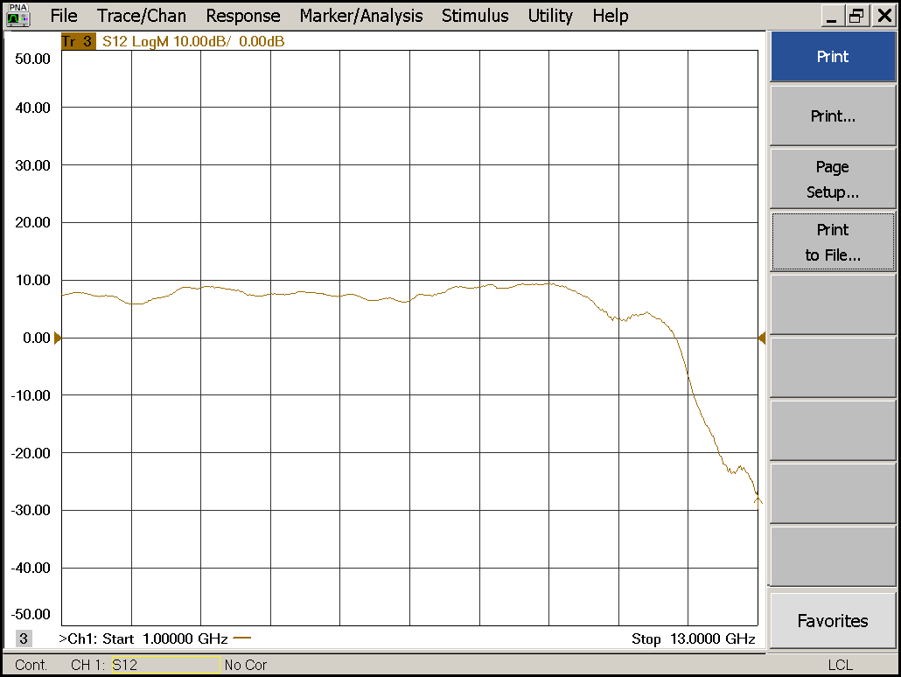

|  |  |  |  |
| --- | --- | --- | --- |
| Flatness: | OK 🗹 NOK 🗆 | Unwanted Features: | Yes 🗆 No 🗹 |

|  |
| --- |
| Y |

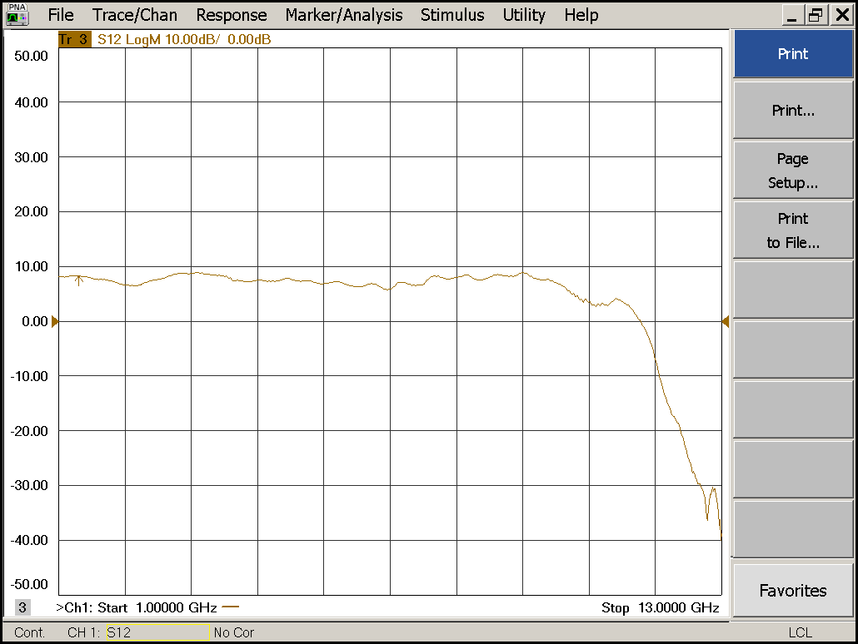

|  |  |  |  |
| --- | --- | --- | --- |
| Flatness: | OK 🗹 NOK 🗆 | Unwanted Features: | Yes 🗆 No 🗹 |

### Power Sweep (Complete Link):

|  |  |  |
| --- | --- | --- |
| Load configuration: Power_Sweep_PAX.csa | | |
| Power Start: -40dBm | Power Stop: -20dBm | Frequency : 4.0GHz |
| PAM Attenuator: 0dB |  | N. Points: 801 |

|  |
| --- |
| X |

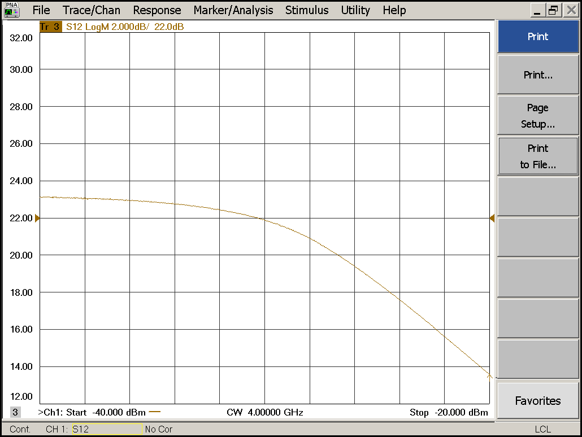

|  |  |  |  |
| --- | --- | --- | --- |
| Compression point: | OK 🗹 NOK 🗆 | Unwanted Features: | Yes 🗆 No 🗹 |

|  |
| --- |
| Y |

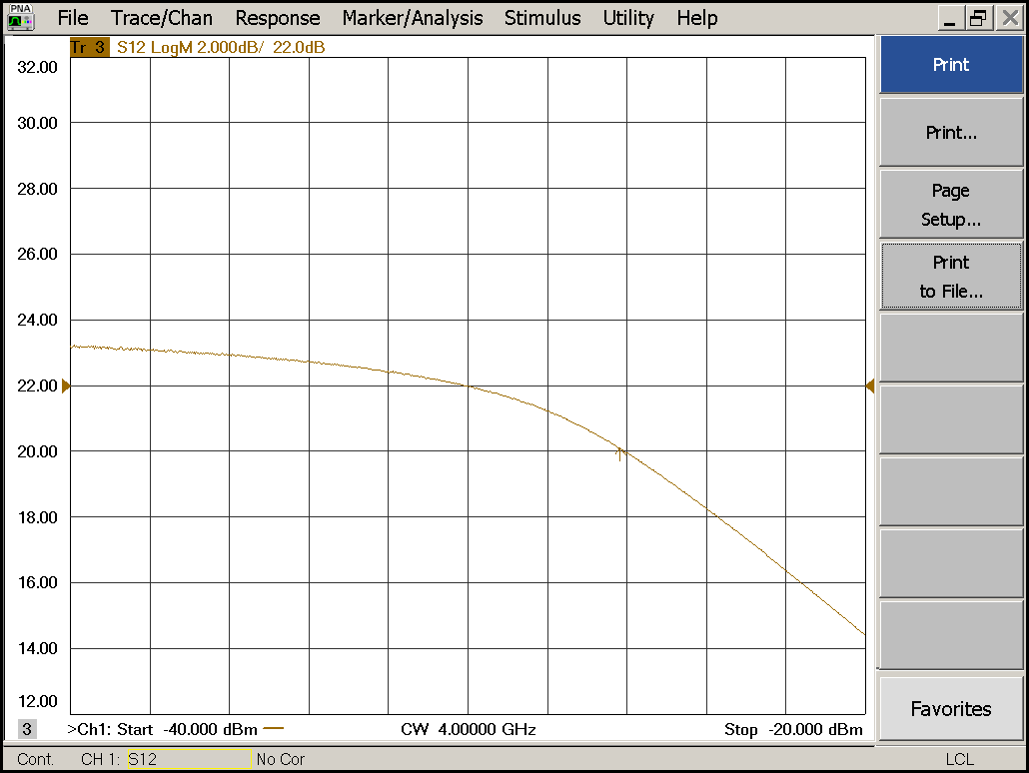

|  |  |  |  |
| --- | --- | --- | --- |
| Compression point: | OK 🗹 NOK 🗆 | Unwanted Features: | Yes 🗆 No 🗹 |

### Detector Calibration and Attenuator Sweep Pol X:

|  |  |  |
| --- | --- | --- |
| Load configuration: Detector_Calibration_PAX.csa | | |
| Freq : 4.0 GHz | Power Level: -20dBm | Sweep Time: -20sec |
| Sweep Mode: CW | Power Level at PAX Input (Measured): -40.6dBm | |

|  |  |  |  |  |
| --- | --- | --- | --- | --- |
| X | | | | |
| CW Input Power [dBm]: | Attenuator Value A [dB]: | Attenuator Value: B [dB]: | Detector Value: | Power Meter  Value [dBm]: |
| -40.6 | 0 | 0 | - | 13.2 |
| -40.6 | 0 | 3 | - | 13.2 |
| -40.6 | 0 | 6 | - | 12.7 |
| -40.6 | 0 | 9 | - | 10.7 |
| -40.6 | 0 | 12 | - | 8.0 |
| -40.6 | 0 | 15 | 0.8533 | 5.2 |
| -40.6 | 0 | 18 | 0.6550 | 1.9 |
| -40.6 | 0 | 21 | 0.3764 | -1.1 |
| -40.6 | 3 | 21 | 0.1908 | -4.5 |
| -40.6 | 6 | 21 | 0.1012 | -7.5 |
| -40.6 | 9 | 21 | 0.0537 | -10.4 |
| -40.6 | 12 | 21 | 0.0280 | -13.3 |
| -40.6 | 15 | 21 | 0.0145 | -16.2 |
| -40.6 | 18 | 21 | 0.0072 | -19.6 |
| -40.6 | 21 | 21 | 0.0039 | -22.6 |
| -40.6 | 24 | 21 | 0.0024 | -25.3 |
| -40.6 | 27 | 21 | 0.0015 | -28.4 |
| -40.6 | 30 | 21 | 0.0011 | -31.5 |
| -40.6 | 30 | 24 | 0.0009 | -34.2 |
| -40.6 | 30 | 27 | 0.0007 | -36.7 |
| -40.6 | 30 | 30 | 0.0008 | -39.1 |

|  |  |  |
| --- | --- | --- |
| Use Noise Source: Atlantic AS6333 | | |
| Freq : 1.0 - 12.0GHz | Power Level: -41.8dBm |  |
| DC Supply: 28V |  | |

|  |  |  |  |  |
| --- | --- | --- | --- | --- |
| X | | | | |
| Input Power [dBm]: | Attenuator Value A [dB]: | Attenuator Value: B [dB]: | Detector Value: | Power Meter  Value [dBm]: |
| -41.8 | 0 | 0 | - | 11.7 |
| -41.8 | 0 | 3 | - | 10.7 |
| -41.8 | 0 | 6 | - | 9.2 |
| -41.8 | 0 | 9 | - | 7.1 |
| -41.8 | 0 | 12 | - | 4.5 |
| -41.8 | 0 | 15 | 0.8528 | 2.0 |
| -41.8 | 0 | 18 | 0.5134 | -1.2 |
| -41.8 | 0 | 21 | 0.2879 | -4.0 |
| -41.8 | 3 | 21 | 0.1494 | -7.0 |
| -41.8 | 6 | 21 | 0.0742 | -10.1 |
| -41.8 | 9 | 21 | 0.0388 | -12.9 |
| -41.8 | 12 | 21 | 0.0195 | -15.8 |
| -41.8 | 15 | 21 | 0.0109 | -18.5 |
| -41.8 | 18 | 21 | 0.0055 | -21.9 |
| -41.8 | 21 | 21 | 0.0032 | -24.9 |
| -41.8 | 24 | 21 | 0.0021 | -27.8 |
| -41.8 | 27 | 21 | 0.0015 | -30.5 |
| -41.8 | 30 | 21 | 0.0012 | -33.7 |
| -41.8 | 30 | 24 | 0.0011 | -36.3 |
| -41.8 | 30 | 27 | 0.0010 | -38.4 |
| -41.8 | 30 | 30 | 0.0010 | -40.4 |

### Detector Calibration and Attenuator Sweep Pol Y:

|  |  |  |
| --- | --- | --- |
| Load configuration: Detector_Calibration_PAX.csa | | |
| Freq : 4.0 GHz | Power Level: -20dBm | Sweep Time: -20sec |
| Sweep Mode: CW | Power Level at PAX Input (Measured): -40.6dBm | |

|  |  |  |  |  |
| --- | --- | --- | --- | --- |
| Y | | | | |
| CW Input Power [dBm]: | Attenuator Value A [dB]: | Attenuator Value: B [dB]: | Detector Value: | Power Meter  Value [dBm]: |
| -40.6 | 0 | 0 | - | 13.3 |
| -40.6 | 0 | 3 | - | 13.3 |
| -40.6 | 0 | 6 | - | 12.6 |
| -40.6 | 0 | 9 | - | 10.6 |
| -40.6 | 0 | 12 | 0.8500 | 7.6 |
| -40.6 | 0 | 15 | 0.7441 | 4.9 |
| -40.6 | 0 | 18 | 0.3975 | 1.5 |
| -40.6 | 0 | 21 | 0.2207 | -1.5 |
| -40.6 | 3 | 21 | 0.1081 | -4.9 |
| -40.6 | 6 | 21 | 0.0557 | -8.0 |
| -40.6 | 9 | 21 | 0.0283 | -11.0 |
| -40.6 | 12 | 21 | 0.0146 | -14.0 |
| -40.6 | 15 | 21 | 0.0077 | -16.9 |
| -40.6 | 18 | 21 | 0.0039 | -20.2 |
| -40.6 | 21 | 21 | 0.0022 | -23.3 |
| -40.6 | 24 | 21 | 0.0014 | -26.3 |
| -40.6 | 27 | 21 | 0.0010 | -29.3 |
| -40.6 | 30 | 21 | 0.0008 | -32.5 |
| -40.6 | 30 | 24 | 0.0006 | -35.1 |
| -40.6 | 30 | 27 | 0.0007 | -37.5 |
| -40.6 | 30 | 30 | 0.0006 | -39.9 |

|  |  |  |
| --- | --- | --- |
| Use Noise Source: Atlantic AS6333 | | |
| Freq : 1.0 - 12.0GHz | Power Level: -41.8dBm |  |
| DC Supply: 28V |  | |

|  |  |  |  |  |
| --- | --- | --- | --- | --- |
| Y | | | | |
| Input Power [dBm]: | Attenuator Value A [dB]: | Attenuator Value: B [dB]: | Detector Value: | Power Meter  Value [dBm]: |
| -41.8 | 0 | 0 | - | 11.6 |
| -41.8 | 0 | 3 | - | 10.6 |
| -41.8 | 0 | 6 | - | 9.0 |
| -41.8 | 0 | 9 | - | 6.9 |
| -41.8 | 0 | 12 | 0.8500 | 4.2 |
| -41.8 | 0 | 15 | 0.5669 | 1.8 |
| -41.8 | 0 | 18 | 0.2940 | -1.5 |
| -41.8 | 0 | 21 | 0.1590 | -4.4 |
| -41.8 | 3 | 21 | 0.0806 | -7.4 |
| -41.8 | 6 | 21 | 0.0394 | -10.5 |
| -41.8 | 9 | 21 | 0.0204 | -13.4 |
| -41.8 | 12 | 21 | 0.0103 | -16.4 |
| -41.8 | 15 | 21 | 0.0060 | -19.0 |
| -41.8 | 18 | 21 | 0.0032 | -22.4 |
| -41.8 | 21 | 21 | 0.0020 | -25.4 |
| -41.8 | 24 | 21 | 0.0015 | -28.4 |
| -41.8 | 27 | 21 | 0.0012 | -31.1 |
| -41.8 | 30 | 21 | 0.0011 | -34.3 |
| -41.8 | 30 | 24 | 0.0009 | -36.8 |
| -41.8 | 30 | 27 | 0.0010 | -38.9 |
| -41.8 | 30 | 30 | 0.0008 | -40.8 |

# Inspection:

### Visual:

|  |  |  |
| --- | --- | --- |
| Fibre Connectors Clean | Comments: | OK 🗹 NOK 🗆 |
| Fibre Connector Mechanical | Comments: | OK **🗹** NOK **🗆** |
| RF Cable | Comments: | OK **🗹** NOK **🗆** |
| RF Connectors Clean | Comments: | OK **🗹** NOK **🗆** |

### Functions:

|  |  |  |
| --- | --- | --- |
| Read Temperature Value | Comments: 31.7 | OK 🗹 NOK 🗆 |
| LNA Settings | Comments: | OK**🗹** NOK **🗆** |
| Temperature Stabilisation | Comments: | OK 🗆 NOK **🗆** |
|  |  | OK 🗆 NOK **🗆** |